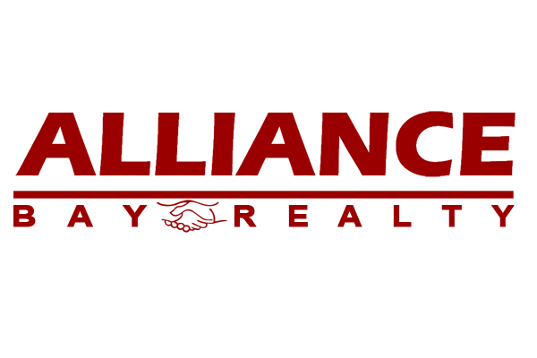

Checklist: Real Estate Owned (REO)

All Reports must be signed and dated by all parties

Property Address: ______________________________________________________________

BOLD=Required: A check will not be issued until the transaction file is complete…..
CAR Form | Agent  Initial
 |  | This checklist
 |  | MLS Listing Printout/Waiver ____ SELM ____
 |  | Final Settlement Statement
AD |  | Disclosure Regarding Real Estate Relationship: Listing Agent
RLA |  | Residential Listing Agreement:___SA ___KLA___ MT ____ PIA ____
PRBS |  | Possible Representation of More than One Buyer or Seller: Listing Agent
REO |  | Real Estate Owned Advisory
AD |  | Disclosure Regarding Real Estate Relationship: Selling Agent
WFA |  | Wire Fraud Advisory
RPA |  | Residential Purchase Agreement ___PEAD-ALL____BIA___PAGE 10___EMD___POF___Pre-Approval ___RR___RRR___EXT___EXT___EXT___COP___CBC___NBP___NSP___FVAC ____ AEA ____PAPA____
CO |  | Counter Offer/s ___1___2___3___4___5___6
ADM |  | Addendum/s ___1___2___3___4___5___6___”AS IS”___SFA___SIP
CR |  | Contingency Removals ___1___2___3___4___EXT___EXT___EXT
SBSA |  | Statewide Buyer and Seller Advisory
TDS |  | Real Estate Transfer Disclosure Statement ___Addendum to TDS
FHDS |  | Fire Hardening Defense Space Disclosures , Advisory, Addendum_______
AVID |  | Agent Visual Inspection Disclosure: Listing Agent ____ Selling Agent ____
ESD |  | Exempt Seller Disclosures
SPQ |  | Seller Property Questionnaire
SA/FIRPTA |  | Seller’s Affidavit of Non-Foreign Status (Use a separate form for each Transferor)
MCA |  | Market Conditions Advisory
WCMD |  | Water-Conserving Plumbing Fixtures and Carbon Monoxide Detector Notice
WDFA |  | Wildfire Disaster Advisory
 |  | Square Footage And Lot Size Advisory And Disclosure
 |  | No Money Passed Advisory___ Electronic Signature Advisory____
FLD |  | Lead-Based Paint & Hazards Disclosure – Homes built before 1978
 |  | City Disclosure (City/County)
 |  | Residential Earthquake Hazard Booklet Receipt – (Homes built before 1960) Built ____
 |  | Alliance Bay Residential Fireplace Disclosure
NHD |  | Natural Hazard Disclosure Statement ____ NHD Report Receipt ____
 |  | Preliminary Title Report:___HOA___CC&R’s___Home Warranty
 |  | Inspections: ___Home___Termite___Roof___Chimney___Pool___Foundation
BIW/BIE |  | Buyer’s Inspection Waiver(BIW)___Buyer’s Inspection Elections (BIE)
VP |  | Verification of Property Condition (Buyer Final Inspection)
CBC |  | Cooperating Broker Compensation Agreement & Escrow Instruction
RCSD-B/S |  | RCSD-B ____RCSD-S ____Trust ____Trust Advisory ____POA ____Entity ____Estate ____
 |  | Broker Demand___ Escrow Term Sheet___

