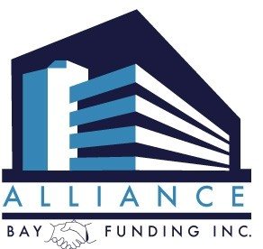
37600 Central Ct. Ste. 264, Newark, Ca 94560
Ph: 510-742-6600 Fax: 510-742-9100

VERBAL AUTHORIZATION TO PULL BORROWER’S CREDIT

I, __________________________have been given verbal authorization to pull and review a full credit report for____________________________________on________________________________. With the borrower’s permission, the credit report was pulled and reviewed prior to the borrower(s) signing a complete loan application.

The reason I received verbal authorization was:
☐ The borrower(s) do not have a property address at this time. Therefore, TRID was not initiated and early disclosures were not required. If this borrower does find a property, initial disclosure will be sent within 3 business days of loan application.
☐ The borrower(s) loan application was completed via phone, mail, internet or fax and the initial disclosures including the “Borrowers Authorization” will be sent within 3 business days of loan
☐Other:__________________________________________________________________________________________________________________________________________________________________________________________________________________________________________________

* If more than one person is listed above, I have spoken with each person and verbally obtained authorization to pull credit

Loan Officer Signature _____________________________ Date_______________________________

Loan Officer Printed Name ____________________________________NMLS#___________________

___________________________________________________________________________________________________
Alliance Bay Funding, Inc. NMLS #249903 Page 1 of 1

